Teacher’s notes – Number Sequences
Year Group 1
Key objective references; Count on and back in ones from any small number, and in tens from and back to zero.
The screens can be used as whole class or paired/ individual activities
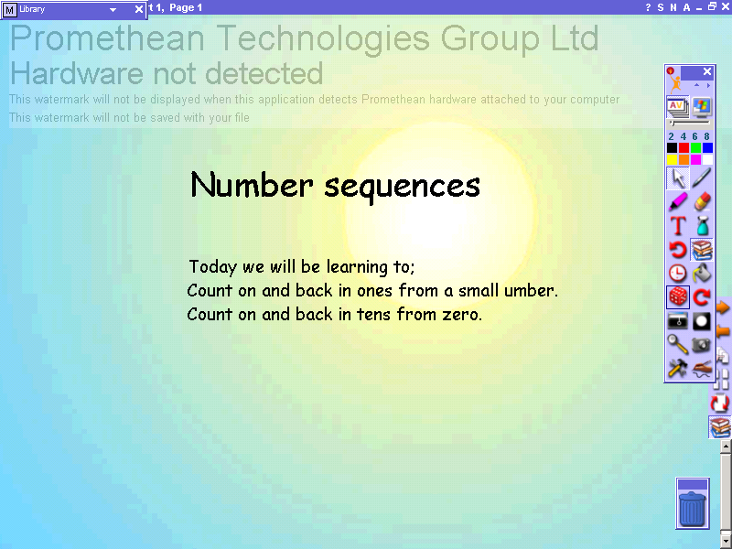 | Title page.  Use orange arrow on left hand side to advance to next screen.
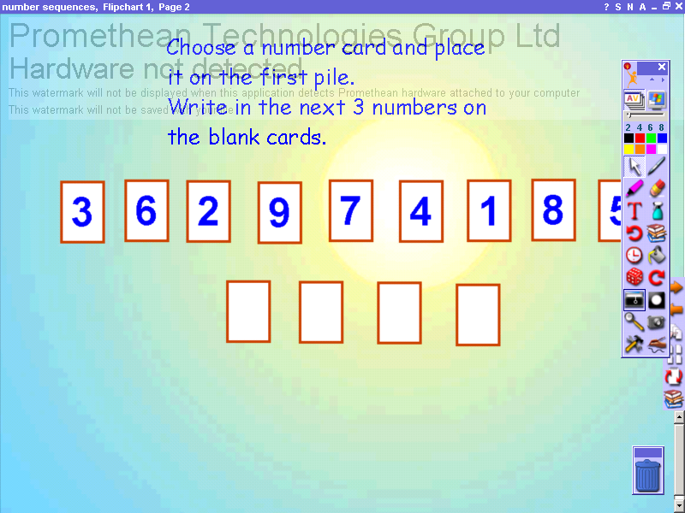 | Click on marquee select tool and use mouse or active pen to click and drag starting number on to first pile.  Click on pen tool and select suitable colour and nib width.  Use to write consecutive numbers on to remaining cards.  Use orange arrow on left hand side to move to next screen
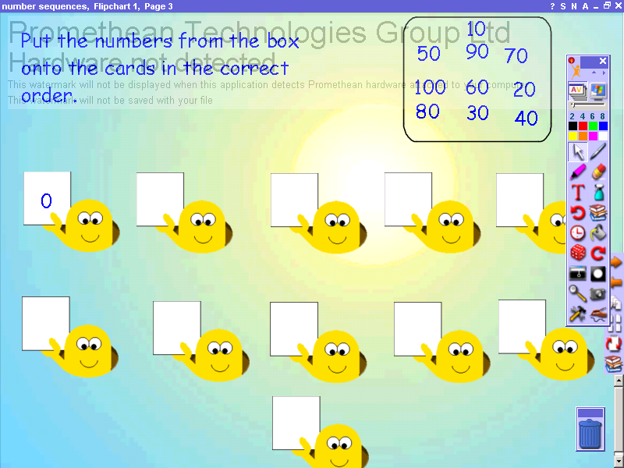 | Click on marquee select tool and use mouse or active pen to click and drag numbers on to blank cards.  Use orange arrow on left hand side to move to next screen
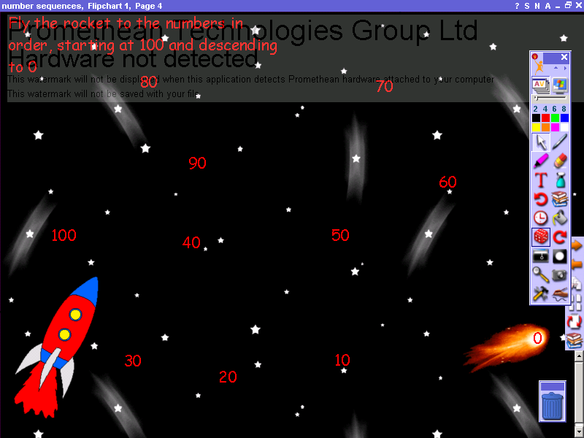 | Click on marquee select tool and use mouse or active pen to click and drag rocket on to numbers in correct order.  Use orange arrow on left hand side to move to next screen
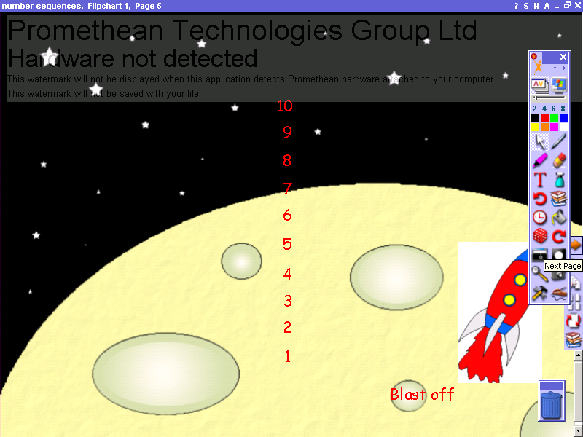 | Click on reveal tool on toolbox to obscure screen.  Click on marquee select tool and using active pen or mouse click on handle and pull down to reveal numbers.  Click on reveal tool to close before using further screens.

